Local publication for call for proposals
EU SUPPORT TO ROMA INCLUSION  Strengthening Local Communities Towards Roma Inclusion  Publication reference: 757/1 | 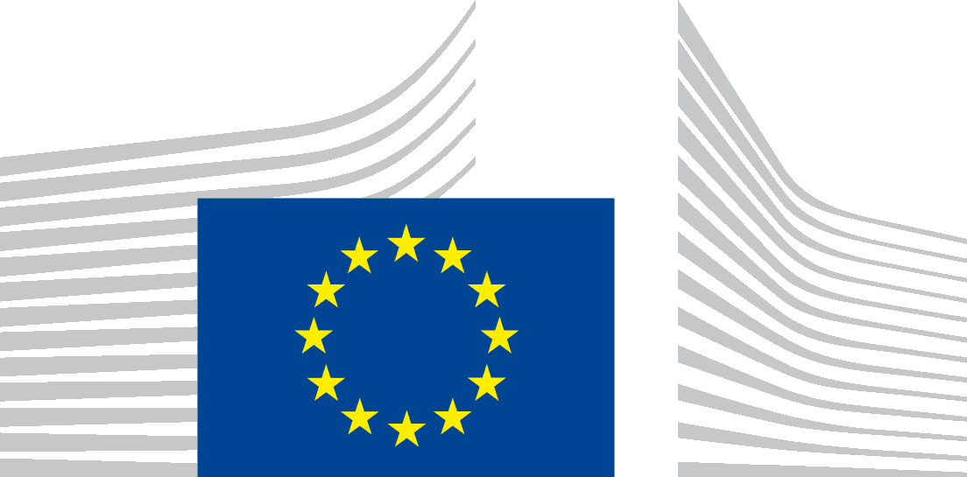
Standing Conference of Towns and Municipalities is seeking proposals for strengthening local communities in the Republic of Serbia towards Roma inclusion, thus improving the position of Roma population in local communities, with financial assistance from the National Action Programme for Serbia IPA 2016 (Instrument for Pre-Accession Assistance II (IPA II)).
The full guidelines for applicants in English, Serbian and Romani language are available for free download on the following internet site:
- SCTM: http://www.skgo.org/strane/337

The deadline for submission of proposals is February 18, 2019. In case of hand deliveries, the deadline for receipt is at 15:00 local time on the same day.

The schedule of the information sessions will be published at a later date in the following websites:
- SCTM: http://www.skgo.org/strane/337

